alter table dropme change column name ename varchar(40);

alter table to add column - alter table student add column col2 varchar(30) after studentname ;

alter table dropme change column id id int after ename ;

alter table to change column name - alter table student change column col2 mycol2 varchar(40) ;

ALTER TABLE dropme MODIFY ename varchar(50) ;

alter table student modify mycol2 varchar(50) ; - to modify column

rename table - rename table student to student2

ALTER TABLE dropme  
ADD PRIMARY KEY (ID);

ALTER TABLE dropme

drop PRIMARY KEY ;

alter table dropme

add foreign key(id) references first_table(id)

alter table dropme

modify ename varchar(50) not null ;

create index ename_ix on dropme(ename);

drop index ename_ix on dropme ;

show indexes from dropme

first show

create table parent ( pid int , pname varchar(50) );

CREATE TABLE child ( cid INT,

parent_id INT,

INDEX (cid),

FOREIGN KEY (parent_id)

REFERENCES parent(pid)

) ;

CREATE TABLE child ( cid INT,

parent_id INT,

INDEX (cid),

FOREIGN KEY (parent_id)

REFERENCES parent(pid)

) ;

throws error

create table parent ( pid int , pname varchar(50) , primary key(pid));

CREATE TABLE child ( cid INT,

parent_id INT,

INDEX (cid),

FOREIGN KEY (parent_id)

REFERENCES parent(pid)

) ;

alter table child drop foreign key child_ibfk_1;

alter table child add foreign key (parent_id) references parent(pid);

1. A FUNCTION always returns a value using the return statement. PROCEDURE may return one or more values through parameters or may not return any at all.
2. Functions are normally used for computations where as procedures are normally used for executing business logic.
3. A Function returns 1 value only. Procedure can return multiple values (max 1024).
4. Stored procedure always returns an integer value of zero by default. Whereas function return types could be scalar or table or table values.
5. Stored procedures have a precompiled execution plan, where as functions are not.
6. A function can be called directly by SQL statement like select func_name from dual while procedures cannot.
7. Stored procedure has the security and reduces the network traffic and also we can call stored procedure in any no. of applications at a time.
8. A Function can be used in the SQL Queries while a procedure cannot be used in SQL queries .that cause a major difference b/w function and procedures.

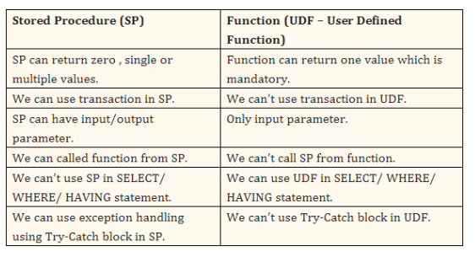

select first_name , min(salary) , department_id

from employees

select department_name , sum(salary) as maxsal

from employees e , departments d

where e.department_id = d.department_id

group by e.department_id

order by maxsal desc limit 1

select department_name , avg(salary) as avgsal

from employees e , departments d

where e.department_id = d.department_id

group by e.department_id

where avgsal > ( select avg(salary) from employees )

CREATE DEFINER=`root`@`localhost` FUNCTION `getCustomerCreditLvl`( creditlimit double ) RETURNS varchar(10) CHARSET utf8

BEGIN

declare lvl varchar(10);

if creditlimit > 50000 then

set lvl = 'PLATINUM' ;

elseif ( lvl <= 50000 and lvl > 10000) then

set lvl = 'GOLD' ;

else

set lvl = 'SILVER' ;

end if ;

RETURN lvl;

END

CREATE DEFINER=`root`@`localhost` PROCEDURE `getEmpName`(IN EMP_ID INT, OUT EMP_FIRST VARCHAR(255))

BEGIN

SELECT FIRST_NAME INTO EMP_FIRST

FROM Employees

WHERE EMPLOYEE_ID = EMP_ID;

END